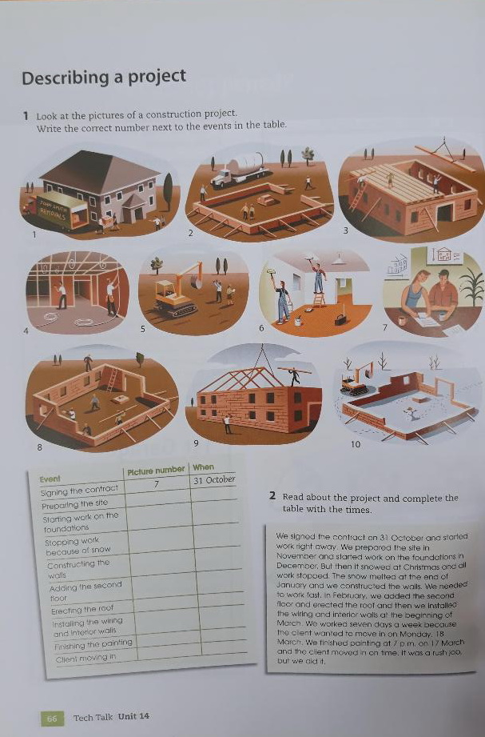
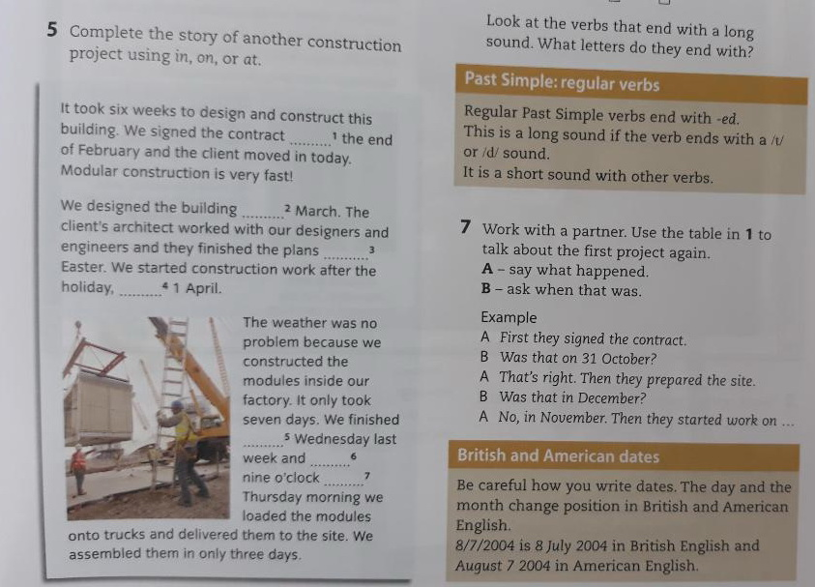

Please watch these two videos on house 3d printing:
https://www.youtube.com/watch?v=wCzS2FZoB-I&ab_channel=TechInsider
https://www.youtube.com/watch?v=lZh8E6zZdzk&ab_channel=CNET

